JACKPOT BINGO

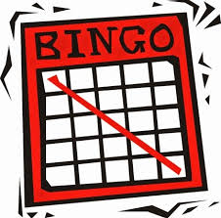
St. Leo Catholic Church
Welcomes everyone to the
St. Leo Church Basement
St. Leo, MN
Sunday, December 4, 2022
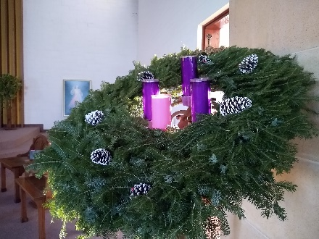
Warm up games at 12:30, Jackpot games at 1:30
Lunch starting at Noon
$200 & $300 Jackpots 18 - $50 Games

Donations $15 per ticket *Handicap Accessible*

This Event is made possible by Catholic United Financial Council #99, St. Leo, MN. Proceeds will help to support Catholic education and other church projects.
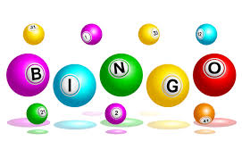

Brian Zitzmann, Sales Representative
1-701-238-3643 bzitzmann@catholicunited.org

